PERSONAL PROFILE
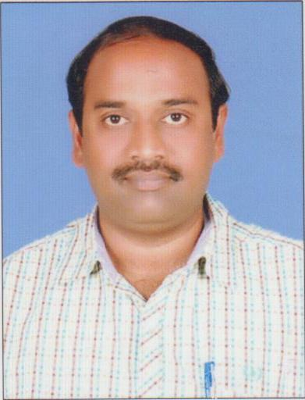
Dr.P.S.KIRAN KUMAR, M.A., M.A. (His) M.Phil., Ph.D
Lecturer in English,
S.K.P Government College,
Guntakal, Anantapur District, Andhra Pradesh,
Mobile: 9290461736
Email: kiranneerada@gmail.com
_________________________________________________________________________________

- Academic Qualifications and Other details:
Subject : ENGLISH
Highest Educational Qualification : Ph.D.,
Employee ID (for regular staff only) : 0751758
Date of Birth : 21.07.1975
Social Category : SC
Religion : HINDU
Gender : MALE
- Date of Joining service as : 22.12.2000
- Lecturer in Degree College : 22.012.2000
- In S.K.P. College, Guntakal : 12.10.2021

- Awards and Achievements : NIL

3. Educational Details:
S.No | Class | Name of the Institution and Place | From | To | % of marks Division | Board/  University
 | SSC
 | Inter
 | UG
 | PG
 | Any other educational Qualifications

- Previous Professional (Teaching) Experience :
S.No | Institution | From | To | Designation | No.of Years
1
2
3
4

API Score for

a)
b)
c)
d)
e)
f)

Papers and Sections handled (2019-20)

S.No | Course | Medium | Title of the Paper

- National / International seminars or Work Shops/Trainings attended :

S.No | National/ International | Institution/place | Date | Title of the paper Presented

6 . Books Authored:

---

7. BOS / Member of Academic Bodies:

---

8. Paper Setting for other academic bodies:

9 . Paper/Journal Publications:

S.No | Title of the Paper | Name of the Journal | Year/Edition | ISSN/ISBN No

10 . Extension Lectures / Invited Lectures Delivered:

S.No | Institution | Topic | Date

11. Any other Curricular/Co curricular/Extracurricular Activities involved

